MERCI HA.1 Mixed Reality with Active Control (prototype)

Abstract
This deliverable is dedicated to the design of a prototype of the hexaphonic HyVibe Guitar, and its test using a standard guitar synthesizer.

- Introduction

The HyVibe company designs the HyVibe System (see Figure 1), a device that transforms guitars into their own loudspeaker, amplifier, effect processor, and looper. No need of pedals or external amplifier, all these features are obtained by the vibration of the soundboard of the guitar itself. The HyVibe System can be installed on almost any acoustic guitar by a guitar technician.

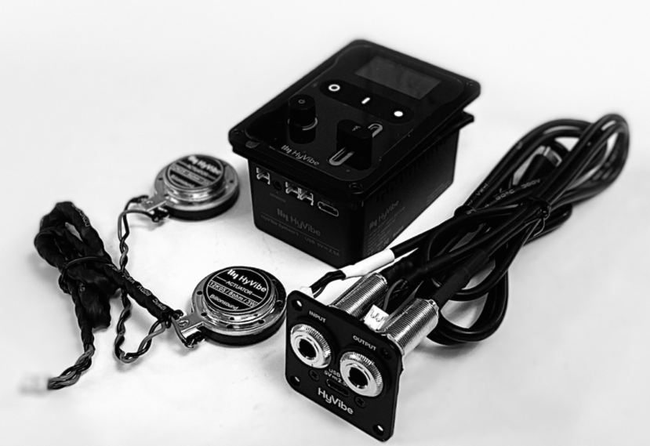

Figure 1: the HyVibe System

The commercial HyVibe System is made of an undersaddle sensor, two inertial actuators and a low latency electronic board. The undersaddle sensor is a flexible piezoelectric cable, that transform its deformation into a proportional electric signal. This signal enters the electronic board, where it is converted into digital and processed sample by sample. The processed signal is converted into analog and sent to the internal amplifier and to the two actuators. The whole process takes only 0.0225 milliseconds. HyVibe recommends gluing the two actuators at the guitar bridge, in order to excite the body close to the string excitation, and then to respect the guitar sound radiation.

This design is not ideal for the ANR MERCI project, especially because polyphonic guitar audio analysis is still a challenge (see HA.2 report). In this context, an hexaphonic HyVibe system prototype is more suitable.

- The hexaphonic HyVibe System prototype

After having studied the state of the art of hexaphonic guitar sensors, it appeared that only a few products were available in the market. They were generally dedicated to electric guitars, which are not suitable for HyVibe as the electric guitar body does not vibrate enough. We finally chose the Graph Tech Ghost Acoustic (see Figure 2).
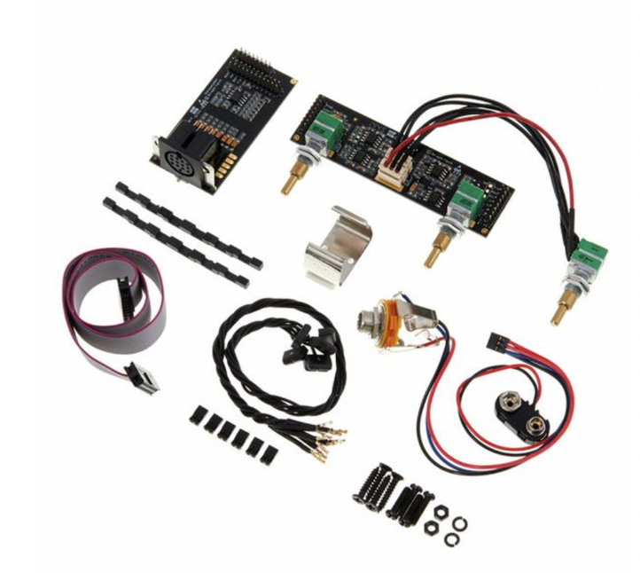
Figure 2: Graph Tech Ghost Acoustic components

Its installation was quite challenging in the Lâg HyVibe dreadnought guitar, due to mechanical integration difficulties. Its final design is presented in Figure 3, where all the components of the hexaphonic sensor are hidden in the interior of the guitar. The two actuators are left outside for more flexibility for the first tests. The main components are:
- Hexaphonic microphone: This microphone is composed of six small piezoelectric sensors. This sensors are put in place of the guitar saddle and each sensor is dedicated to measure the vibration of one string.
- 6 Channels preamplifier: The preamplifier provides six high impedance audio inputs, designed to be connected to each sensor of the hexaphonic microphone. Each channel has its output present on the 13 pin jack connector mounted on the guitar body. The six audio outputs are low impedance, line level, hence ready to be connected with a cable to a MIDI synthetizer.
- Tone Control board: This board provides a additional monophonic output that mixes the 6 channels of the hexaphonic microphone. It allows to connect a classic guitar amplifier and get the whole sound of the guitar. Beside that a three frequencies tone control is available in order to shape the sound.
- Power supply
All the system embedded in the guitar is powered by a standard 9V battery. The power is switched on by plugging a cable in the guitar.

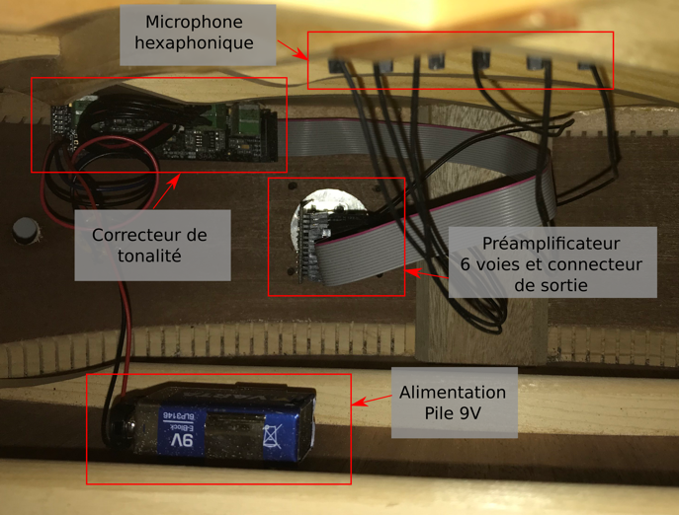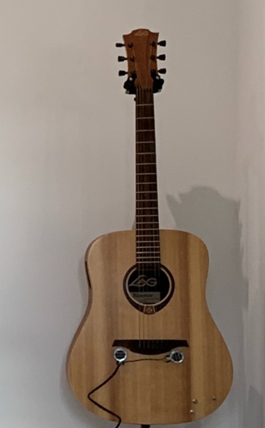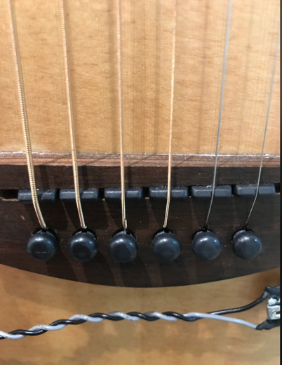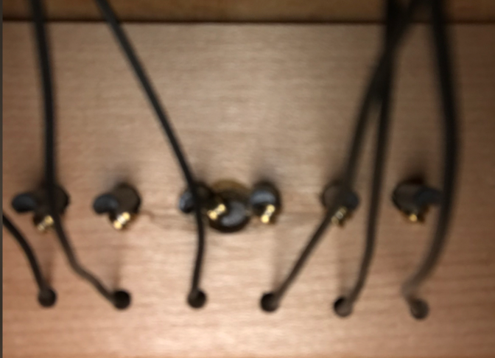

Figure 3: The HyVibe guitar prototype with hexaphonic sensor

